**SHOPSMART PROJECT REPORT**

**1. INTRODUCTION**

**1.1 Project Overview**

**ShopSmart – Your Digital Grocery Store Experience** is a full-featured web application designed to streamline online grocery shopping for customers while providing powerful management tools for sellers and administrators. The platform allows users to browse products, manage carts, place orders, and make secure payments. Sellers can efficiently handle inventory and fulfill orders, while admins oversee user activity and system performance.

Built with a modern tech stack, ShopSmart ensures a secure, responsive, and user-friendly experience tailored to the evolving needs of digital commerce.

**1.2 Purpose**

The purpose of this project is to provide a user-friendly digital platform that connects customers with grocery sellers efficiently. It ensures:

* Make grocery shopping easy and convenient online.
* Help sellers manage products and orders quickly.
* Give users a smooth and friendly shopping experience.
* Keep payments and personal data safe and secure.
* Let admins control and monitor the platform effectively.

**2. IDEATION PHASE**

**2.1 Problem Statement**

Customers often struggle with traditional grocery shopping due to long queues, limited store hours, and lack of real-time product availability, leading to frustration and wasted time.

How Might We:

How might we enable customers to shop for groceries easily and efficiently from the comfort of their home?

**2.2 Empathy Map Canvas**

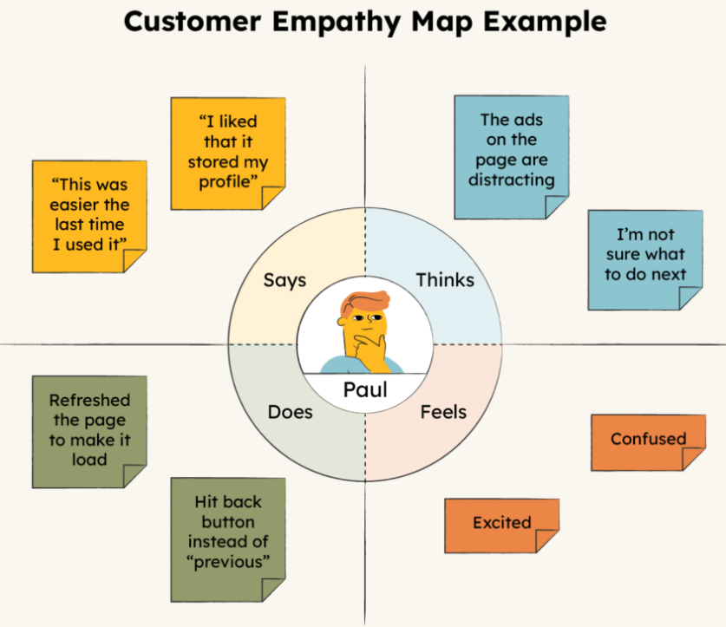

**Says:** “I wish I could order groceries online without going to the store.”

**Thinks:** “Why can’t I see what’s in stock before I plan my meals?”

**Feels:** Frustrated, stressed by time-consuming store visits and out-of-stock items.

**Does:** Browses multiple apps or websites, visits stores in person, checks availability manually.

**2.3 Brainstorming**

During the brainstorming session, the team explored ideas such as:

* Personalized product recommendations using AI
* Real-time price comparison across retailers
* Smart shopping list with budget tracking
* Integration with local store inventories

**3. REQUIREMENT ANALYSIS**

**3.1 Customer Journey Map**

The customer journey includes the following key stages:

* Awareness: User discovers the app through ads, referrals, or app stores.
* Registration/Login: New users sign up; returning users log in securely.
* Product Search & Discovery:: Users browse or search for products using filters like category, price, and availability.
* Smart Cart & Price Comparison: Adds items to cart with real-time price comparisons across stores.
* Checkout & Payment: Reviews the cart, applies coupons, selects payment and delivery options.
* Order Confirmation & Tracking: Receives confirmation and tracks order status via app notifications or email.
* Post-Purchase Engagement: Gets personalized offers, delivery feedback requests, and spending insights.

**3.2 Solution Requirement**

Functional Requirements:

* User Registration and Login (Customer & Retailer)
* Browse Products by Filters (category, price, brand, availability)
* Add to Cart, Purchase, or Remove Items
* Smart Price Comparison Across Stores
* Apply Coupons and Track Orders
* Admin Dashboard for Inventory & Sales Monitoring

Non-Functional Requirements:

* Fast loading time (<2 seconds)
* Secure data handling (PCI-DSS compliance for payments)
* Mobile-responsive design
* High uptime (99.9%)

**3.3 Data Flow Diagram**

External Entities: Customer, Retailer, Admin

Processes:Registration, Product Search, Order Placement, Price Comparison

Data Stores: Users DB, Product Catalog DB, Orders DB

**3.4 Technology Stack**

* Frontend: Angular.js / Flutter (for mobile)
* Backend: Node.js / Django
* Database: MongoDB / PostgreSQL
* Authentication: Firebase Auth / JWT
* Hosting: AWS / Firebase Hosting

**4. PROJECT DESIGN**

**4.1 Problem-Solution Fit**

The proposed solution addresses the problem of scattered product information and inefficient shopping by providing a unified platform for smart, real-time product comparison and seamless online purchases.

**4.2 Proposed Solution**

A web and mobile application where:

* Customers can search, compare, and purchase products across multiple retailers
* Retailers can manage inventory, pricing, and promotions
* Admins can oversee platform activity, moderate listings, and ensure system integrity

**4.3 Solution Architecture**

Architecture Type: Client-Server Model

Layers:

* Presentation Layer: Web/Mobile UI for customer and retailer interaction
* Business Logic Layer: RESTful API server handling search, pricing, and order processing
* Data Layer: Product databases, user profiles, and transaction records stored in the cloud

**5. PROJECT PLANNING & SCHEDULING**

5.1 Project Planning

Agile Methodology was used with sprints of 6 days each:

Sprint-1: 16 June 2025 - 18 June 2025:User Registration & Authentication

Sprint-2: 19 June 2025 – 20 June 2025: Product Search & Smart Price Comparison

Sprint-3: 21 June 2025 - 23 June 2025: Cart Management & Order Placement

Sprint-4: 24 June 2025 - 26 June 2025: Payment Gateway Integration & Review System

**6. FUNCTIONAL AND PERFORMANCE TESTING**

**6.1 Performance Testing**

**Tools Used:**

* JMeter for load and performance testing
* Postman for API functionality and response testing

**Test Scenarios:**

* Simulated 100 concurrent shoppers browsing and placing orders
* Measured API response time (<1.5 sec)
* Evaluated database performance for product search and order placement
* Checked database query performance

**7. RESULTS**

* Application handled peak load smoothly
* Average response time: 1.2 seconds
* No crashes or timeouts recorded

7.1 Output Screenshots:

HOME PAGE :

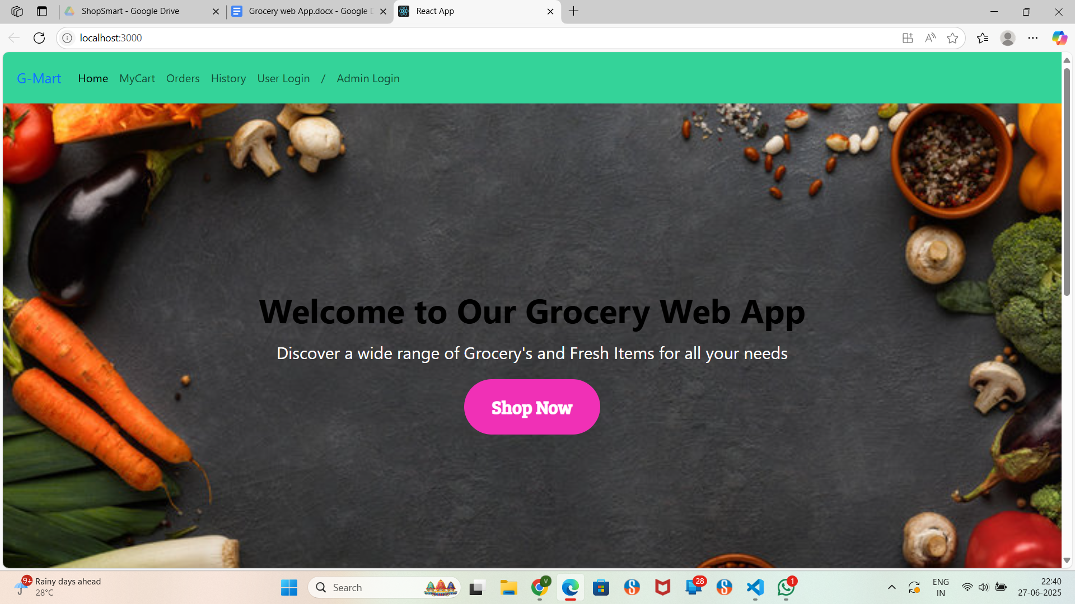

LOGIN PAGE:

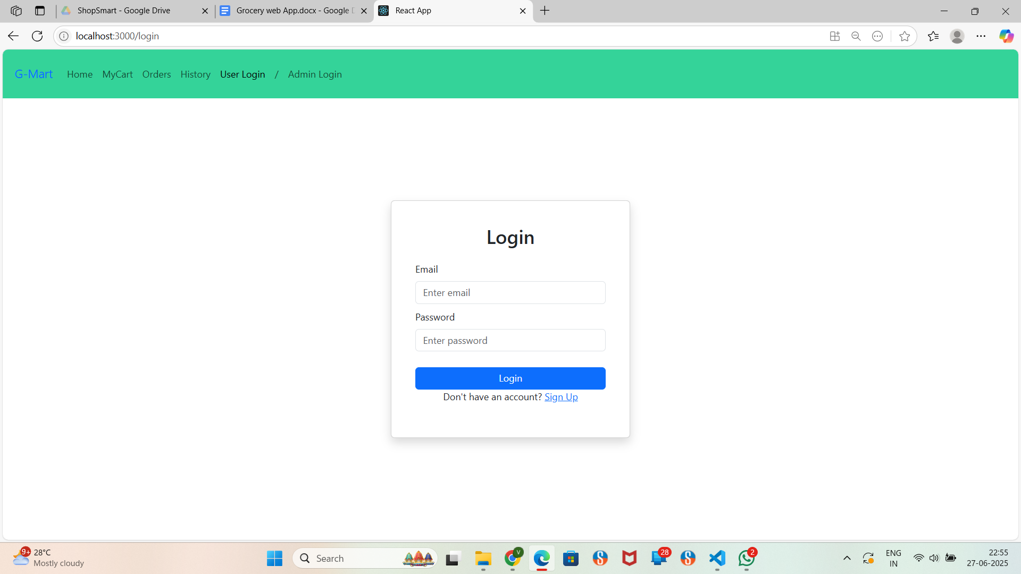

DASHBOARD :

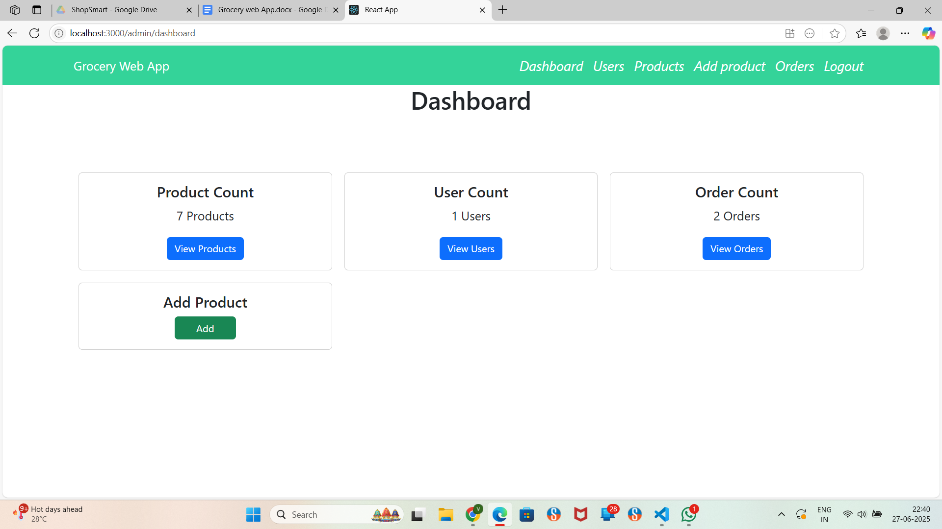

PRODUCTS:

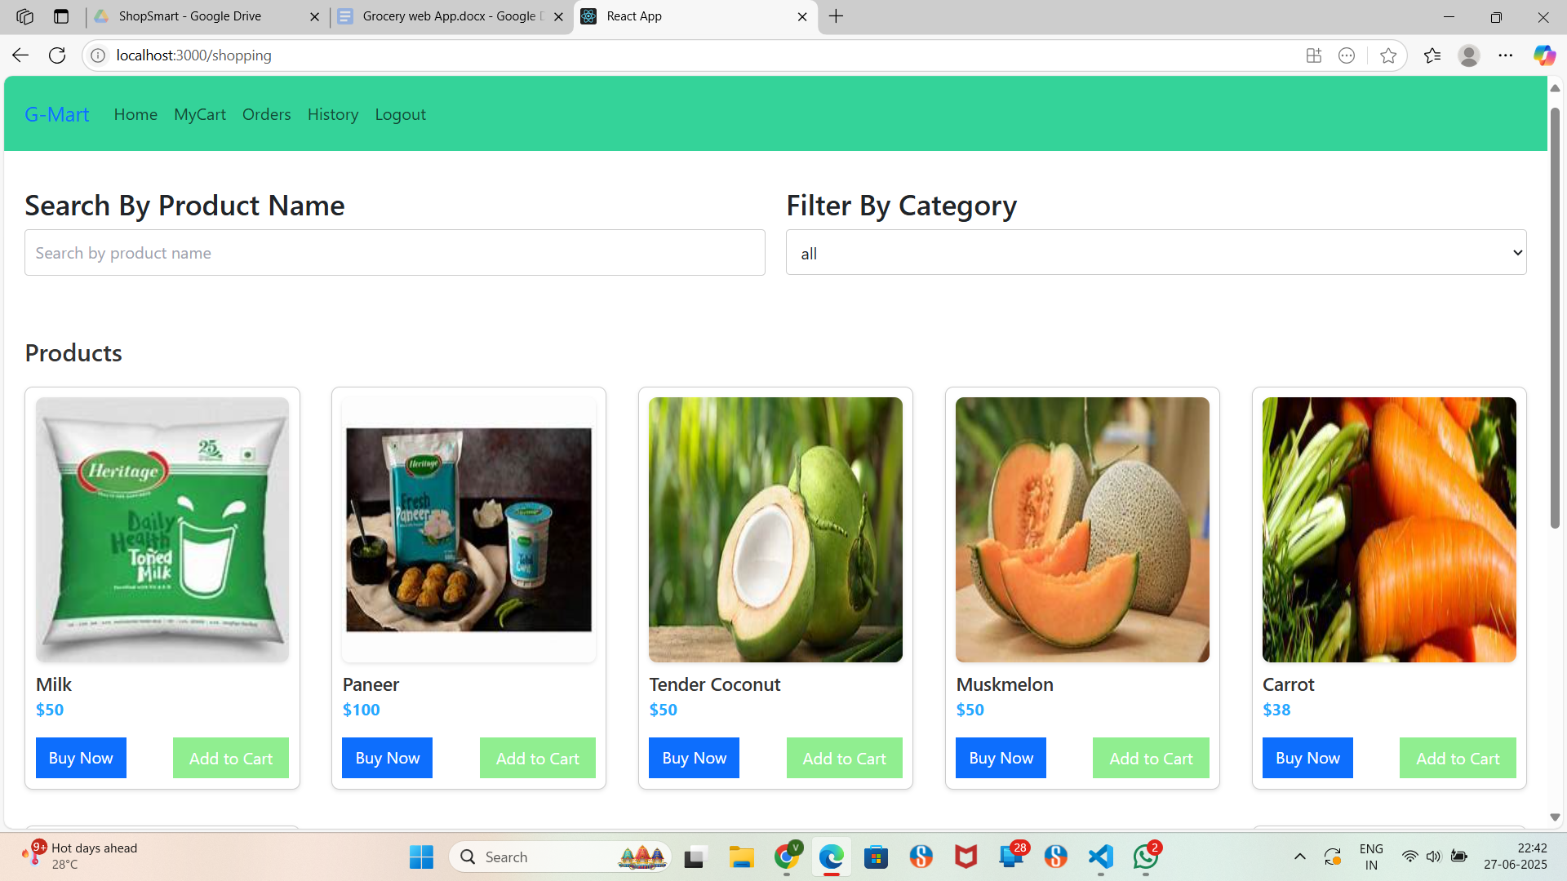

**8. ADVANTAGES & DISADVANTAGES**

Advantages:

* Saves time on grocery shopping
* Easy product search and filtering
* Convenient home delivery
* Contactless and secure payments
* Simplifies inventory and order management for sellers

Disadvantages:

* Requires stable internet connection
* Delivery delays during peak hours
* May lack the in-store product touch-and-feel experience
* Some users may face initial difficulty navigating the app

**9. CONCLUSION**

The ShopSmart project successfully delivers a seamless digital grocery shopping experience. By utilizing modern web technologies and user-centric design, the platform enhances convenience, optimizes product management, and improves overall customer satisfaction.

**10. FUTURE SCOPE**

* Integration with real-time delivery tracking
* AI-based personalized product recommendations
* Voice-enabled search and ordering
* Multi-language and regional support
* Expansion to include local farmers and organic markets

**11. APPENDIX**

Source Code:

<https://github.com/varsshi-12/ShopSmart-Web-App>